**CONCRETE BEAM DESIGN REPORT**

**Step 1: Problem Identification and Statement**

The objective is to design a software that helps to design a concrete beam which will be supported on two masonry walls 200 mm thick. The software asks the user to enter the length, permanent load and variable load and then in turn calculates the beam depth, width, beam self-weight, total characteristic load, shear force and bending moment. If the user enters a negative value for any of the inputs, the software gives and error message which requires user to re-enter their values.

**Step 2: Gathering Information**

We can use the length of the beam to calculate the depth and width and we can use the permanent and variable load of the beam to work out its total characteristic load, shear force and bending moment provided that a safety margin of 60% must be included for the permanent load and 20% for the variable load. The reinforced concrete unit weight (Cuw) is a constant value of 25 kN/m3 .

A) Beam Size:

Depth of the beam (mm) = Length / 14

Width of the beam (mm) = 0.4 * depth

B) Total Characteristic Load:

Beam self-weight = Depth * Width * Reinforced Concrete Unit

Total characteristic permanent action = Beam self-weight + permanent load

C) Shear Force and Bending Moment:

First we need to calculate the Design Action:

Design Action = (1+ PERMANENT_LOAD_MARGIN) *Permanent load + (1 + VARIABLE_LOAD_MARGIN) * Variable load

Shear force: Design Action *L/2

Bending moment: M = Design Action* L2/8

Depth (mm)

Width (mm)

Length (m)

The total characteristic load (kN/m)

Permanent Load (kN/m)

Shear Force (kN)

Variable Load (kN/m)

Bending Moment (kNm)

The following menu is presented to the user to enter the length, permanent load and variable load.

This software designs a rectangular beam. Enter the beam specifications:

Length (m): 6

Permanent load (gk, kN/m): 10

Variable load (qk, kN/m): 8

The program calculates and outputs the depth, width, total characteristic load, shear force, and bending moment.

Here is a summary of the beam design:

The minimum values for the size of the beam are:

Depth: 429 mm

Width: 172 mm

The total characteristic load: 11.8367 kN/m

Shear Force (V): 76.8 kN

Bending Moment (M): 115.2 kNm

Enter -1 to exit or any other number to repeat.

**Step 3: Test Case and Algorithm**

The formulas given above are used to determine the beam size, total characteristic load, shear force and bending moment of the rectangular reinforced concrete beam. The beam size refers to the dimensions of the beam which are calculated from the length of the beam provided by the user. To calculate the total characteristic load, first the beam self-weight is calculated using the dimensions and the constant reinforced concrete unit. This value when in turn added to the permanent load gives the user the total characteristic load. Shear force and bending moment are calculated by first calculating a value for the design action and then using the formulas provided above. If the user inputs the length, permanent load and variable load as 5, 10 and 4 respectively, the output would be as provided below:

Depth: 357.1 mm

Width: 142.8 mm

Beam self-weight: 1.276 N

Total characteristic permanent action: 11.2755 kN/m

Design Action: 11.2

Shear Force: 52 kN

Bending Moment: 65 kNm

These input/output values serve as one test case. The following table provides a set of test cases that can be used to test the algorithm and software.

|  |  |  |  |  |  |  |  |  |
| --- | --- | --- | --- | --- | --- | --- | --- | --- |
| Test Case | Length /m | Permanent Load /kN/m | Variable Load /kN/m | Depth /mm | Width /mm | The total characteristic load /kN/m | Shear Force /kN | Bending moment /kNm |
| 1 | 0 | 0 | 0 | N/A | N/A | N/A | N/A | N/A |
| 2 | 5 | 10 | 4 | 358 | 143 | 11.2755 | 52 | 65 |
| 3 | 387 | 903 | 145 | 27643 | 11057 | 8544 | 313238 | 30305757 |
| 4 | -4 | 6 | -7 | N/A | N/A | N/A | N/A | N/A |

Algorithm:

Main() Function

Declare variables gk, qk, L, h, b, Ws, TCPA, Wd, V, M as double

Declare variable Cuw

Assign the value 25 to Cuw

Declare variable PERMANENT_LOAD_MARGIN

Assign the value 0.60 to PERMANENT_LOAD_MARGIN =

Declare variable VARIABLE_LOAD_MARGIN

Assign the value 0.20 to VARIABLE_LOAD_MARGIN

Declare variable choice as integer

Repeat

Repeat

Print “This software designs a rectangular beam. Enter the beam specifications: “ newline

Print “Length (m): ”

Read value into L

Print “Permanent load (gk, KN/m): ”

Read value into gk

Print “Variable load (qk, KN/m): ”

Read value into qk

if L< 0 or gk<0 or qk<0

Print “Invalid selection. Please enter a positive value.” newline

while L<0 or gk<0 or qk<0

Assign L / 14 to h

Assign 0.4*h to b

Assign h*b*Cuw to Ws

Assign Ws + gk to TCPA

Assign (1+ PERMANENT_LOAD_MARGIN)gk + (1 + VARIABLE_LOAD_MARGIN)qk to Wd

Assign Wd*L / 2 to V

Assign Wd*L*L / 8 to M

Print "Here is a summary of the beam design:" newline

Print "The minimum values for the size of the beam are:" newline

Print "Depth: " h*1000 “mm” newline

Print "Width: " b*1000 ”mm” newline

Print "The total characteristic load: " TCPA “kN/m” newline

Print "Shear Force (V): " V “kN” newline

Print "Bending Moment (M): " M “kNm” newline

Print "Enter -1 to exit or any other number to repeat." newline

Read value into choice

while choice is not equal to -1

End

**Step 4: Code or Implementation**

The C++ program to solve our problem is listed below.

/*-------------------------------------------------*/

/* Name: Ishmal Khalid, Net ID: ik1299 */

/* Date: September 13, 2019. */

/* Program: Assignment.cpp */

/* Description: This program designs a rectangular beam. */

/*-------------------------------------------------*/

#include <iostream>

#include <cmath>

using namespace std;

int main()

{

// Declare and initialize the variables

double gk, qk, L, h, b, Ws, TCPA, Wd, V, M;

const double Cuw = 25;

const double PERMANENT_LOAD_MARGIN = 0.60;

const double VARIABLE_LOAD_MARGIN = 0.20;

int choice;

//Repeat while choice is not equal to -1

do {

//Repeat while L, gk or qk is less than or equal to 0

do{

//Print and read beam specifications

cout << "This software designs a rectangular beam. Enter the beam specifications:" << endl;

cout << "Length (m): ";

cin >> L;

cout << "Permanent load (gk, kN/m): ";

cin >> gk;

cout << "Variable load (qk, kN/m): ";

cin >> qk;

//Validate specifications are positive

if (L <= 0 || gk <= 0 || qk <= 0){

cout << "Invalid selection. Please enter a positive value." << endl;

}

} while (L <= 0 || gk <= 0 || qk <= 0 );

//Calculate dimensions

h = (L / 14); // Calculates depth

b = (0.4*h); // Calculates width

//Calculate Total Characteristic Load

Ws = h*b*Cuw; // Calculates beam self-weight in kN/m

TCPA = Ws + gk; // Calculates beam Total Characteristic Permanent Action

//Calculate Shear Force and Bending Moment

Wd = (1 + PERMANENT_LOAD_MARGIN)*gk + (1 + VARIABLE_LOAD_MARGIN)*qk; // Calculates Design Action

V = Wd*L / 2; // Calculates Shear Force

M = Wd*L*L / 8; // Calculates Bending Moment

//Print calculated values

cout << "Here is a summary of the beam design:" << endl;

cout << "The minimum values for the size of the beam are:" << endl;

cout << "Depth: " << ceil(h * 1000) << " mm" << endl;

cout << "Width: " << ceil(b * 1000) << " mm" << endl;

cout << "The total characteristic load: " << TCPA << " kN/m" << endl;

cout << "Shear Force (V): " << V << " kN" << endl;

cout << "Bending Moment (M): " << M << " kNm" << endl;

//Print and read choice to repeat program

cout << "Enter -1 to exit or any other number to repeat." << endl;

cin >> choice;

} while (choice!=-1 );

return 0;

}

**Step 5: Test and Verification**

Test Case 1:

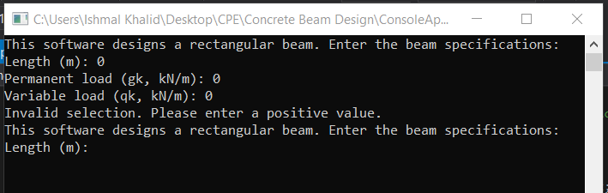

Test Case 2: 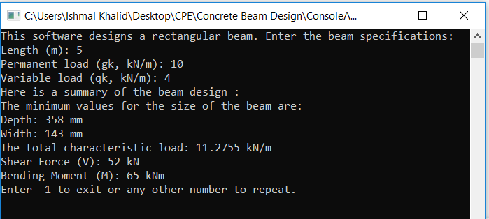

Test Case 3:

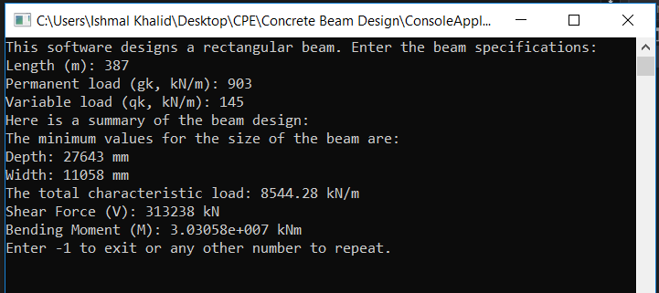

Test Case 4:

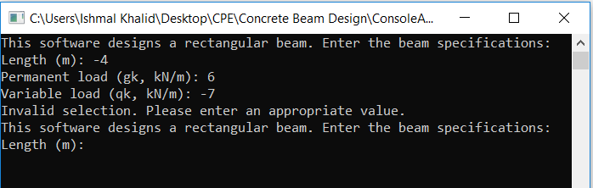

Test case 5:

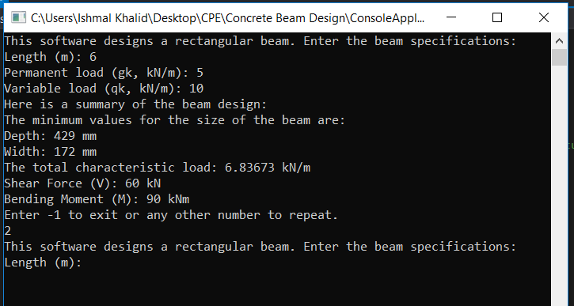

All four test cases are in agreement with the test case expected output. The slight difference in depth and width values is due to the fact that the calculated values are being rounded up to give a whole number answer in the program. In the fourth test case, no calculations are performed by the program as negative values are inputted for length and variable load and the program gives an error message. In the fifth test case, 2 is entered instead of -1 and the program is repeated again which shows the loop is working correctly. Hence, we can conclude that the program is functioning correctly.

**User Guide**

This software is used to design a rectangular reinforced concrete beam. The software asks the user to enter the length, permanent load and variable load and then in turn calculates the beam depth, width, beam self-weight, total characteristic load, shear force and bending moment. If the user enters a negative value for any of the inputs, the software gives and error message which requires user to re-enter their values.

To terminate the software, simply press -1.